## The Sign Editor

To open the Sign Editor, select **View** and tick the **Sign Editor** box. The palette will then appear at the base of your screen.

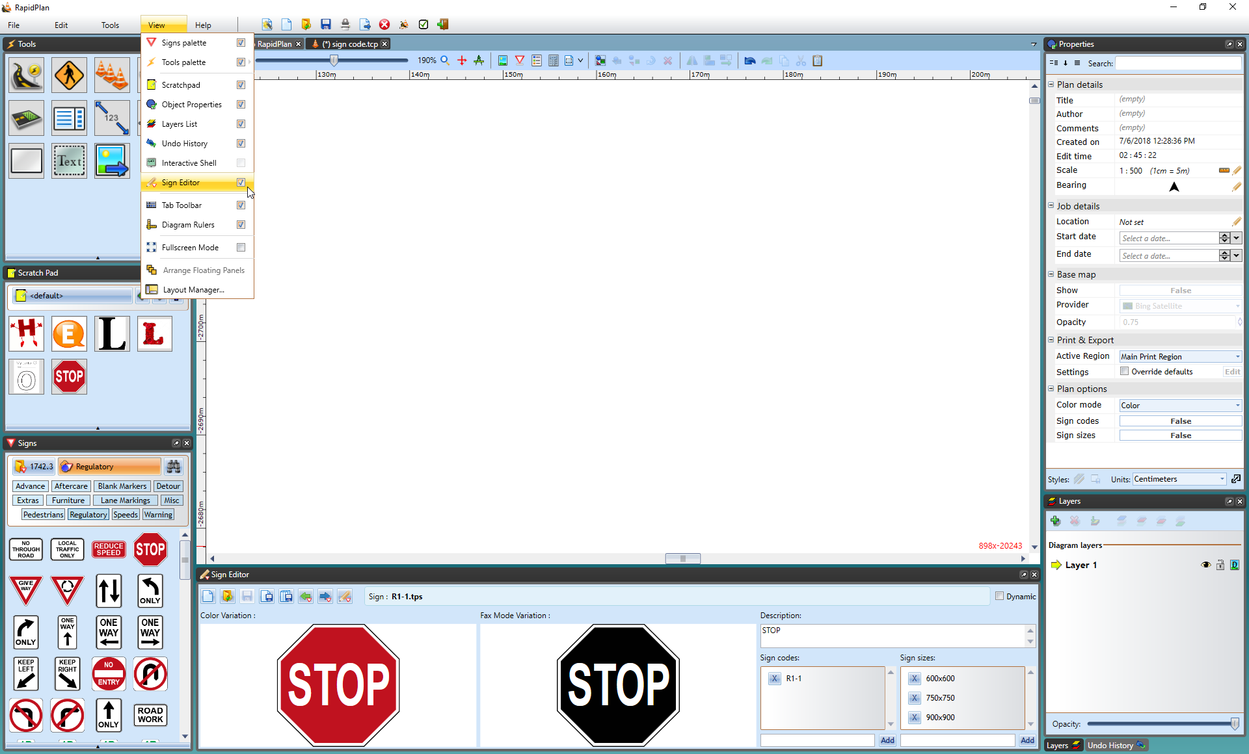

Opening_the_Sign_Editor_Palette

**How to use the Sign Editor**

In the Sign Editor you can:

* Produce and Save Sign Variations
* Edit Sign Variations
* Add a Sign Description
* Add Sign Codes
* Add Sign Sizes

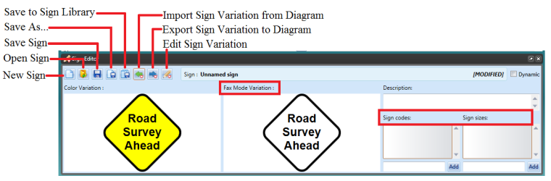

sign editor palette

## Opening a Sign into Sign Editor

To open a sign in the Sign Editor you have two options;

1. **Select “Open Sign” option** - use to access saved files from your computer
2. **Select “Import Sign Variation From Diagram” option** - use to open a sign from your canvas

Once you have constructed your base sign in RapidPlan, select the sign on the canvas and select **Import Sign Variation From Diagram** in the Sign Editor. As you can see the editor will immediately provide a Fax Mode version of your sign for you.

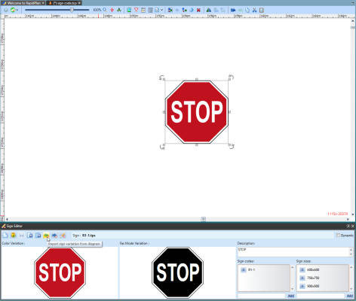

Importing_Sign_From_Canvas_to_the_Sign_Editor

## Editing Sign Variations in Sign Editor

Now that there are two signs, your standard sign and the fax mode variation, you can edit them as separate signs.

To do this either click on the desired sign directly in Sign Editor which will take you to the quick edit window, or select the **Edit Sign Variation** icon and select the sign from there.

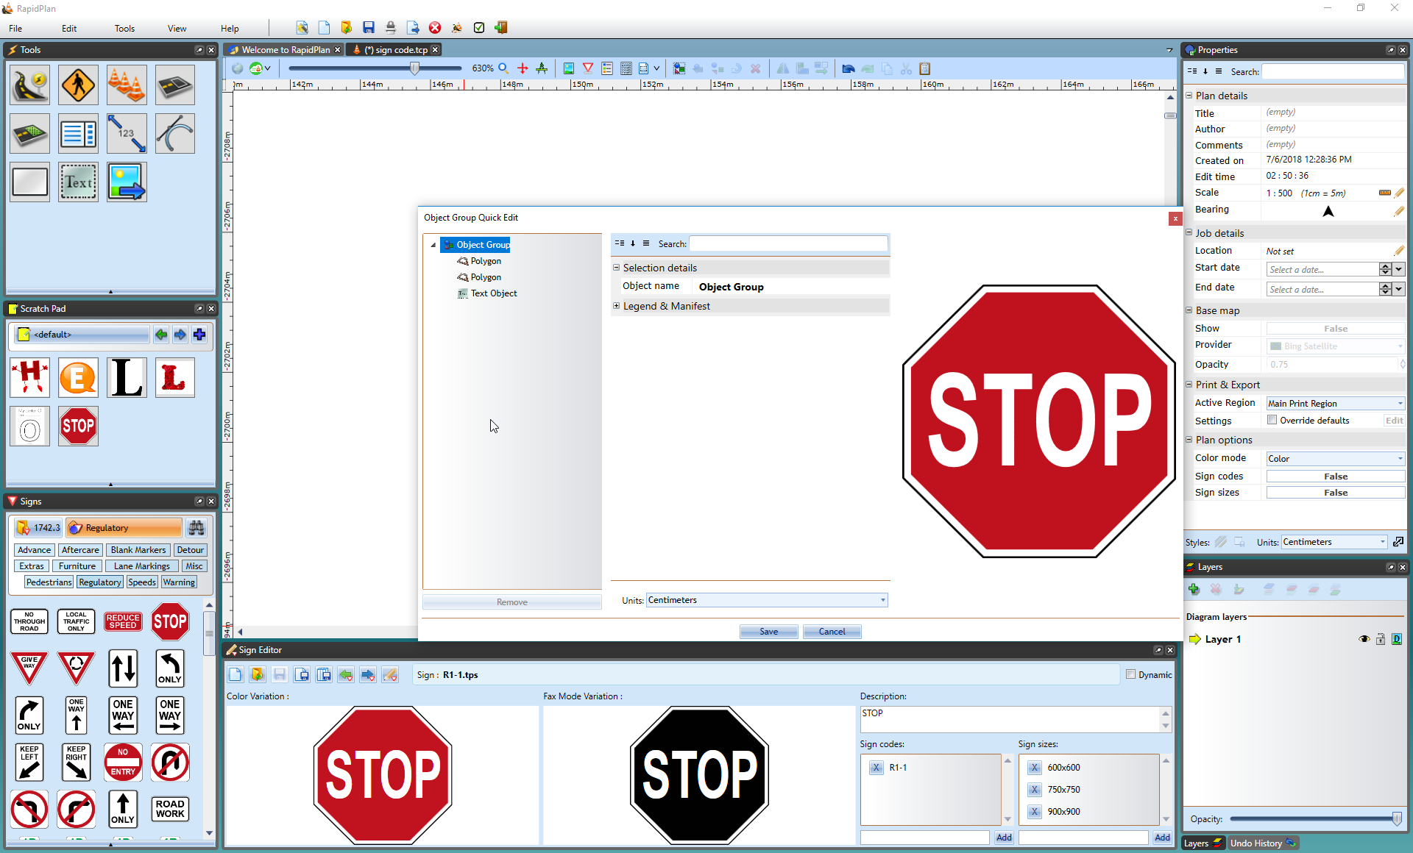

Quick_Edit_Sign_Variation_Option

As you can see in Resources/Quick_Edit_Sign_Variation_Option.png, the **Quick Edit** window is the same as discussed in other sections of RapidPlan, where you change the object’s properties as usual.

### Adding Sign Description, Codes and Sizes to your Sign

Adding a description for you sign, and/or codes and sign sizes is very easy in the Sign Editor.

**To Add a Designation Code to your Sign:**

* Enter your desired code in the section below **Sign Codes**.
* Select **Add**.
* Once you have completed your sign, select **Save to Library** to save your sign and all its variations to the Sign Palette.
* 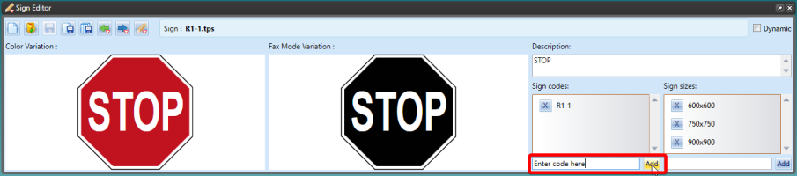
* Adding_a_Code_to_your_Sign
* **Note**: You must save your sign (either to your computer or to the Signs Palette) in order to use all of its edited variations.

### Saving your Sign and its Variations

In the Sign Editor you can save your sign and variations to your computer by selecting the **Save As…** icon in the Sign Editor Palette or you can choose to **Save to Sign Library** where you can choose its location within the Sign Palette. For example, in the image below the sign is being saved to the **NSW** package under the **Custom** tab in the Signs Palette. All of the sign’s variations will be saved here.

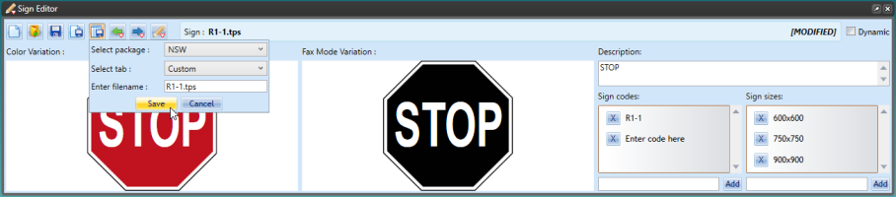

Save_to_Sign_Library

**Note**: Toggle Fax and Sign Codes modes from the Options toolbar to see your completed sign with all the variations we’ve created.